Rendezvous Problem

Team 12 , Shyamprasad V Atri ,Spandana K R , Parikshit B G , Kartik M Kerur

AIM

To have the robots meet at the same location

PROCEDURE

Taking two robots into consideration

Let two robots be in position x1 and x2

We can control the velocities say u1 and u2

So u1=(x2-x1)/dt u2=(x1-x2)/dt

[u1 , u2]’=[-1,1;1,-1]*[x1 , x2]’

So input state parameters x=[x1 , x2]’

Control parameters=[u1,u2]’

Output state parameter is also position y=[x1 , x2]’

<x1>----------------------------------------<x2>

A=[-1 , 1;1 , -1]

B=[0,0]’

C=[1 , 1]

D=0

function rendezvous

A=[-1 1;1 -1];

B=[0;0];

C=[1,1];

D=0;

ran=ss(A,B,C,D);

[eig_vec,eig_val]=eig(A)

step(ran)

%[resp,t]=impulse(ran);

%plot(t,resp)

end

eig_vec =

0.7071 0.7071

-0.7071 0.7071

eig_val =

-2 0

0 0

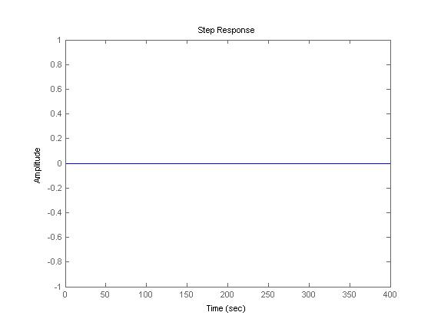

#!/usr/bin/env python

from numpy import *

from scipy import *

from pylab import *

from scipy.integrate import odeint

from scipy.signal import lti,step

from matplotlib import pyplot as plt

from control import *

# THIS IS THE ORIGINAL PROGRAM. DO NOT CHANGE ANYTHING

A=([-1,1],[1,-1])

B=([0],[0])

C=[1,1]

D=0

sys_plant=ss(A,B,C,D)

w,v=eig(A)

#Tt=input('total_time')

#n=input('number_of_steps')

t=r_[0:0.05:100j]

T,yout=step_response(1*sys_plant,t)

yout,T=impulse(sys_plant,t)

plt.plot(T,yout)

plt.show()

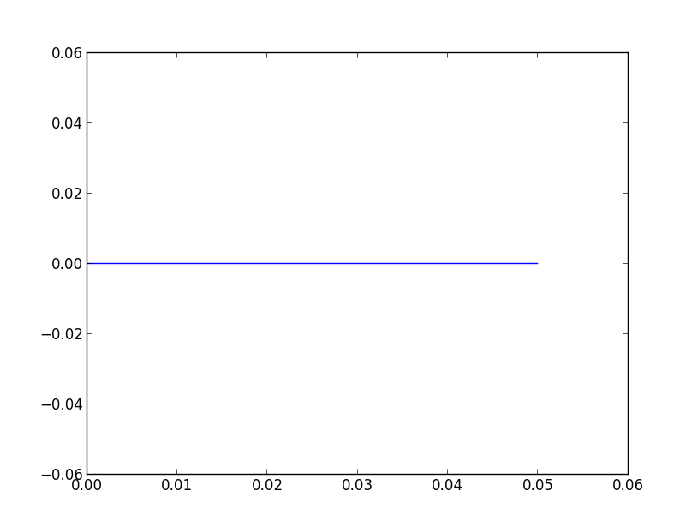

from the Eigen value computation we see that

λ1=-2 and λ2=0

we see that system has one zero Eigen value so the system is critically stable and hence we calculate the Eigen vector and see that Eigen vector corresponding to λ2=0 is 0.71,0.71 which implies that both robots reach the rendezvous location

for many robot the equation will be

x(i)=∑(1,j,n)(x(j)-x(i))

and A=[-(n-1),1,1….;1,-(n-1),1,1….;1,1,…..,-(n-1)]

and when solved for Eigen value one of the value is zero so the system is critically stable and hence will reach the same location that is the centroid of the system.

